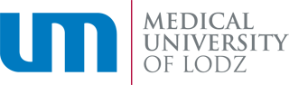

Resolution no. 34/2015
of 1 June 2015
The Rector of the Medical University of Lodz
Refers to establishing the amount of Rector’s Award for outstanding academic achievements for students of Medicine, Dental Medicine and Nursing of the Division of Studies in English Language.

Pursuant to Article 66, Paragraph 2 of the Act of 27 July 2005 –Higher Education Act (Journal of Laws of 2012, Point 572 with later amendments) and § 47, Paragraph 2, Point 10 of the Resolution of the Senate of the Medical University of Lodz of 29 September 2011, with later amendments, I declare as follows:
§ 1
The Rector’s Award for outstanding academic achievements for students of Medicine, Dental Medicine and Nursing of the Division of Studies in English Language amounts to 5000 PLN.

§ 2
The Resolution comes into force on the day it is signed.

RECTOR
Prof. Paweł Górski, MD, PhD

Copied to:
- Organizational Units
- The Medical University of Lodz website

